**FORM 4 PREDICTOR 2,2025**

**kenya Certificate of Secondary Education**

**312/1 - ­­ Geography - Paper 1**



**PREDICTOR 2 – Time - 2 ¾ hours**

**Name …………………………………………….……… Adm Number…………………………..**

**Candidate’s Signature ………………….…...……….. Date ……………………………………**

**Instructions to students**

1. Write your name, admission number and class in the spaces provided above.
2. This paper consists of two section **A** and **B**
3. Answer all the questions in section A
4. Answer **question 6** and any other two questions from section **B**
5. All you answer **must** be written in the spaces provided in this question paper.
6. Candidates should answer the questions in English.

**For Examiner’s use only**.

|  |  |  |  |
| --- | --- | --- | --- |
| **Section** | **Question** | **Maximum’s**  **Score** | **Candidate’s**  **Score** |
| **A** | **1-5** | **25** |  |
| **B** | **6** | **25** |  |
|  | **7** | **25** |  |
|  | **9** | **25** |  |
|  | **10** | **25** |  |
| **100**  **Total** |  |

TURN OVER

**SECTION A**

**Answer all the questions in this section**

1. (a) What is the relationship between Geography and Mathematics? (2 marks)

(b) Identify three branches of Geography (3 marks)

**2.** (a) Use the diagram below to answer the questions that follow.

|  |
| --- |
|  |

1. What type of eclipse is represented by the diagram? (1 mark)
2. Explain how the above eclipse occurs. (2 marks)

(b) What is the time at Malindi on 40° E, when the time at Accra on Longitude 0° is 12.00 noon?

(3 marks)

**3.** (a) Apart from fold mountains, name three other features resulting from folding. (3 marks)

(b) State two factors that determine the folding of crustal rocks. (2 marks)

**4.** (a) Give three reasons why some lakes in Kenya have saline water. (3 marks)

(b) Outline two economic uses of lakes. (2 marks)

**5.** (a) What is natural vegetation? (2 marks)

(b) State three characteristics of the Mediterranean type of vegetation. (3 marks)

**SECTION B**

**Answer question 6 and any other two questions from this section.**

**6.** Study the map of Mumias 1:50,000 (Sheet 101/2) provided and answer the following questions.

(a)(i) Identify two types of scales that have been used in the map extract. (2 marks)

(ii) What was the magnetic declination of Mumias as at January 1965? (2marks)

(iii)Name three districts covered by the map of Mumias. (2marks)

(iv)Measure the length of the dry weather road from the junction at grid reference 6028 up to the bridge at grid reference 6434. Give your answer in KM (2marks)

(b) (i) Reduce by two, the area to the East of Easting 50 and enclosed by Northing 30 to 40. (2 marks)

On it mark and name;

* River Nzoia (1mark)
* All weather road loose surface (1mark)
* District boundary (1mark)
* Seasonal swamp (1mark)

(ii) Calculate the scale of the reduced area (2marks)

(c) Describe the drainage of the area covered by the map. (5 marks)

(d) Citing evidence from the map, identify two economic activities carried out in the area covered by the map. (4marks)

**7**. (a) (i) Define the term rock. (2marks)

(ii) Describe the following characteristics of minerals;

* Tenacity (2marks)
* Lustre (2marks)
* Cleavage (2 marks)

(b) (i) Name two examples of extrusive igneous rocks. (2marks)

(ii) Describe the formation of Plutonic rocks. (4marks)

(c) Explain three significance of rocks to the economy of Kenya. (6 marks)

(d) Your class is planning to carry out a fieldwork on rocks around your school.

(i) Outline two activities you would engage in before the study. (2 marks)

(ii) State three challenges you are likely to face during the field study. (3 marks)

**8.** (a) (i) Outline any two types of river erosion. (2 marks)

(ii) State three factors that influence river erosion. (3 marks)

(b) Describe how the river erodes through the following processes.

(i) Hydraulic action. (4 marks)

(ii)Solution (2 marks)

(c) Describe how the following features are formed.

(i) Interlocking spurs. (4 marks)

(ii) Natural levees. (4 marks)

(d)Explain three negative effects of rivers to the human environment. (6 marks)

**9.** (a) (i) Differentiate between Vulcanicity and Volcanicity. (2 marks)

(ii) Describe how a lava plateau is formed. (4 marks)

(b) The diagram below shows some intrusive features formed by vulcanicity.

Use it to answer the questions that follow.

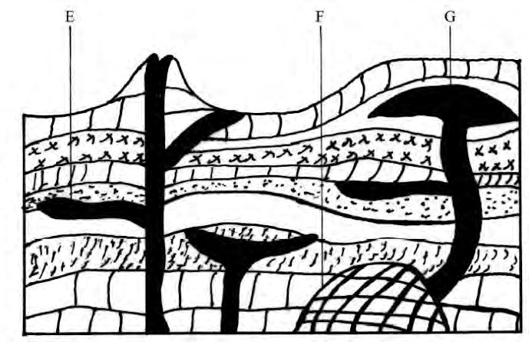

1. Name the features marked E, F and G. (3 marks)
2. Explain how the feature marked E is formed. (4 marks)

(c ) Students carried out a field study on volcanic rocks.

1. Give four reasons why it is necessary to collect rock samples during such a field study. (4 marks)
2. Outline four follow up activities the learners would be engaged in after the field study.(4mks)

(d)Give four causes of earth quakes. (4 marks)

**10.** (a) (i) What is a soil catena? (2 marks)

(ii) Give three factors that determine the colour of soil. (3 marks)

(iii)State three ways in which mulching helps in soil conservation. (3 marks)

(b) Explain how the following farming practices causes soil erosion.

(i) Burning (4 marks)

(ii) Over cultivation (4 marks)

(c ) Give two economic uses of soil (2 marks)

(d) You are supposed to carry out a field study of an eroded area.

(i) State three methods you would use to control soil erosion. (3 marks)

(ii) Give two disadvantages of using secondary sources of collecting data in this kind of study.

(2 marks)

(iii)Identify two methods you would use to record the observations. (2 marks)

**THIS IS THE LAST PRINTED PAGE**